**PURBANCHAL UNIVERSITY**

**Biratnagar Nepal**



A Project report on

**“SMART BLIND STICK”**

**In the partial fulfillment for the requirement of the 3rd Semester Project-III (subject code- BIT 206CO) in the completion of Bachelor of Information Technology (BIT) degree at KIST college of Information Technology, under Purbanchal University.**

|  |  |  |  |  |  |  |  |  |
| --- | --- | --- | --- | --- | --- | --- | --- | --- |
|  | **Submitted By: -** | | |  | | **Submitted To: -** | | |
| **1)** |  | **Priya Kushawaha** |  | |  | |  |  | |
| **2)** |  | **Samira Shahi** | | | **Purbanchal University** | | | | |

**Under The Guidance of**

**Mr. Kiran Khanal**

**KIST COLLEGE OF INFORMATION AND TECHNOLOGY KAMALPOKHARI, KATHMANDU NEPAL**

**KIST COLLEGE OF INFORMATION AND TECHNOLOGY KAMALPOKHARI, KATHMANDU NEPAL**

**CERTIFICATE**

This is to certify that the project work entitled **“SMART BLIND STICK”** is carried out by **PRIYA KUSHAWAHA (5431), SAMIRA SHAHI (5434),** bona fide students of **KIST COLLEGE OF INFORMATION AND TECHNOLOGY** in partial fulfillment for the award of **BACHELOR IN INFORMATION AND TECHNOLOGY** of the **PURBANCHAL UNIVERSITY, BIRATNAGAR NEPAL**, during the year **2022-2023**. It is certified that all corrections indicatedfor internal assessment have been incorporated in the report submitted in the department library. The project report has been approved, as it satisfied the academic requirements in respect of the project work prescribed for the said degree.

The details of the students are as follows: -

|  |  |  |
| --- | --- | --- |
| **NAME** | **REGISTRATION NO.** | **SYMBOL NO.** |
| Priya Kushawaha | 058-3-2-04730-2020 | 333705 |
| Samira Shahi | 058-3-2-04737-2020 | 333712 |
|  |  |  |
|  |  |  |

Course Semester: - 3rd Semester

Subject: - Project-III

Subject Code: - BIT206CO



Mr. Deepak Khadka

Program Coordinator, BIT



**KIST COLLEGE OF INFORMATION AND TECHNOLOGY KAMALPOKHARI, KATHMANDU**

**Examiner’s Certification**

The Project Report

On

**“SMART BLIND STICK”**

**Developed by**

**Priya Kushawaha**

**Samira Shahi**

Is approved and is acceptable in qualify form.

**Internal Examiner External Examiner**

Name: Name:

Designation: Designation:

# ACKNOWLEDGEMENT

It is with greatest satisfaction and euphoria that we are submitting our project report entitled **“SMART BLIND STICK”.** We have completed it as a part of the curriculum of **PURBANCHAL UNIVERSITY.**

We would like to express our deepest appreciation to all those who provided us the possibility to complete this project.  A special gratitude to our **PROJECT MANAGER** **Mr. Kiran Khanal** who guided us throughout the project.

We are indebted to all members of **KIST College,** for the valuable support and suggestion provided by them using their specific fields’ knowledge. We are grateful for their cooperation during the period of our project.

Finally, we would also like to express our gratitude to **PURBANCHAL UNIVERSITY** who gave us the beautiful opportunity to explore this wonderful project. This project helped us in doing a lot of research and we came to know about so many new things we are really thankful.

We hope the university will accept our attempt as a successful project.

Thank you!

**PRIYA KUSHAWAHA(333705)**

**SAMIRA SHAHI (333712)**

**Table of Contents**

ACKNOWLEDGEMENT 4

Abstract 7

Chapter 1 8

Introduction 8

1.1 Introduction 8

1.2 Objectives 9

1.3 Features 10

1.4 Advantages 10

1.5 Disadvantages 10

1.6 Team Structure and Role 11

Chapter 2 12

System analysis 12

2.1 Hardware components 12

Arduino Uno 12

Ultrasonic Sensor 13

PIEZO BUZZER 13

JUMPER WIRES 13

9V BATTERY 14

2.2 Working Principle 14

Chapter 3 15

System Design 15

3.1 Algorithm 15

3.2 Proteus Schematic Circuit Diagram 16

3.3 Block diagram 17

3.4 Connections 18

3.5 Arduino code 19

3.6 Gantt chart 22

Chapter 4 23

System Development and Implementation 23

4.1 Software Specifications 23

4.2 Hardware Specifications 23

Chapter 5 24

Conclusion 24

5.1 Conclusion 24

5.2 Future scope 24

References 25

# Abstract

Our project **“Smart Blind Stick”** describes ultrasonic blind walking stick with the use of Arduino. According to **WHO**, 30 million peoples are permanently blind and 285 billion peoples with vision impairment. If you notice them, you can very well know about it they can’t walk without the help of other. One has to ask guidance to reach their destination. They have to face more struggles in their life daily life. Using this blind stick, a person can walk more confidently. This stick detects the object in front of the person and give response to the user either by vibrating or through command. So, the person can walk without any fear. This device will be best solution to overcome their difficulties.

# Chapter 1

# Introduction

## Introduction

Visually impaired persons have difficulty to interact and feel their environment. They have little contact with surroundings. Physical movement is a challenge for visually impaired persons, because it can become tricky to distinguish obstacles appearing in front of them, and they are not able to move from one place to another. They depend on their families for mobility and financial support. Their mobility opposes them from interacting with people and social activities. In the past, different systems were designed with limitations without a solid understanding of the nonvisual perception. Researchers have spent the decades to develop an intelligent and smart stick to assist and alert visually impaired persons from obstacles and give information about their location. Over the last decades, research has been conducted for new devices to design a good and reliable system for visually impaired persons to detect obstacles and warn them at danger places. Smart walking stick is specially designed to detect obstacles which may help the blind to navigate care-free. This system presents a concept to provide a smart electronic aid for blind people, both in public and private space. The proposed system contains the ultrasonic sensor and electric buzzer. The proposed system detects the obstacle images which are present in outdoor and indoor with the help of a camera. The stick measures the distance between the objects and smart walking stick by using an ultrasonic sensor. When any objects or obstacles come in range of an ultrasonic sensor and it make buzzer sound.

## 1.2 Objectives

Some specific objectives of making a smart blind stick could include:

* **Detecting obstacles:** Using sensors such as ultrasonic or infrared sensors, the smart blind stick can detect obstacles in the user's path and provide feedback through vibrations, sounds, or other mechanisms to alert the user.
* **Guiding the user:** Using feedback mechanisms such as LED lights, the smart blind stick can guide the user towards their intended destination or provide directional cues to help them navigate around obstacles.
* **Increasing safety:** By providing real-time feedback about the user's environment, a smart blind stick can help prevent accidents and promote safety in a variety of settings, such as on sidewalks, in crowded areas, or in unfamiliar environments.
* **Enhancing independence:** A smart blind stick can help individuals with visual impairments to move around independently and with greater confidence, improving their quality of life and sense of autonomy.

## 1.3 Features

* Detects obstacles using an ultrasonic sensor.
* Alerts the user through a buzzer when an obstacle is detected.
* Measures the distance between the user and obstacles in real-time.
* Provides adjustable sensitivity settings.
* Offers buzzer feedback.
* Portable, lightweight, and easy to use.
* Low power consumption for longer battery life.

## 1.4 Advantages

* Auto Detection
* Simple to use and low cost
* Fully paperless system
* With little software and sensor upgradation, can be extensible to any other application and specification

## 1.5 Disadvantages

* Limited and fixed route to follow daily routine.
* Till now, GPS can’t attach in it due to 40 meter to change coordinates as to follow the new path.
* Little sensor support in these fields

## 1.6 Team Structure and Role

The members assigned specific tasks and duties are responsible for completing those responsibilities to achieve the project goals:

|  |  |  |  |  |  |
| --- | --- | --- | --- | --- | --- |
| **Members** | **Study and analysis** | **Designing** | **Coding**  **and hardware** | **debugging** | **Documentation** |
| Priya  Kushawaha | Priya  Kushawaha | Priya  Kushawaha | Priya  Kushawaha | Priya  Kushawaha | Priya  Kushawaha |
| Samira  Shahi | Samira  Shahi |  |  | Samira  Shahi | Samira  Shahi |

# Chapter 2

# System analysis

A system analysis of a smart blind stick made using Arduino would involve examining the different components and functions of the device and how they work together to achieve the desired functionality.

## 2.1 Hardware components

* ARDUINO UNO
* HC-SR04 ULTRASONIC SENSOR
* BUZZER
* JUMPER WIRE
* 9V BATTERY

## Arduino Uno

* The Arduino Uno is a microcontroller board based on the ATmega328P chip.
* It has 14 digital input/output pins and 6 analog inputs.
* It can be programmed using the Arduino IDE, which is based on Processing.
* It is easy to use, low cost and versatile.
* It is popular for hobbyist and professional projects such as robotics and home automation.

## Ultrasonic Sensor

* The HC-SR04 Ultrasonic Sensor is a popular sensor used for measuring distance.
* It uses ultrasonic sound waves to detect objects and determine their distance.
* The sensor has a range of 2cm to 400cm, and can detect objects with high accuracy.
* It works by sending a pulse of ultrasonic waves and measuring the time it takes for the waves to bounce back from an object.
* The HC-SR04 is widely used in robotics, drones, and automation applications due to its low cost, small size, and ease of use.

## PIEZO BUZZER

* Piezo buzzers produce sound using a crystal.
* They are commonly used in Arduino projects and controlled by code.
* Different sounds can be generated by changing the frequency and duration of the digital signal.

## JUMPER WIRES

* Jumper wires are used to make temporary connections in electronics.
* They come in different lengths and colors for easy circuit modification.
* They are often used with breadboards for easy circuit prototyping and testing.

## 9V BATTERY

* 9V batteries are small, rectangular-shaped batteries commonly used in electronic devices.
* They are typically made of six small 1.5V cells connected in series.
* 9V batteries are commonly used in smoke detectors, remote controls, and other small electronic devices.

## 2.2 Working Principle

The working principle of this device involves the use of ultrasonic waves to detect obstacles and a buzzer to alert the user.

Here's how it works:

* **Ultrasonic Sensor:** The smart blind stick is equipped with an ultrasonic sensor that sends out high-frequency sound waves. These sound waves bounce off any objects in the user's path and are then received by the sensor.
* **Distance Calculation:** The time taken for the sound waves to bounce back to the sensor is measured, and this information is used to calculate the distance between the user and the obstacle.
* **Buzzer Alert:** If the distance between the user and the obstacle is less than a certain threshold value, the buzzer is activated to alert the user of the obstacle's presence.
* **User Feedback:** The user can then adjust their path or take any necessary action to avoid the obstacle.

# Chapter 3

# System Design

## 3.1 Algorithm

1. Declare constants trigPin, echoPin, buzzerpin, ledpin and variables duration and distance(cm).
2. In the setup() function:
   * Initialize the Serial Monitor with a baud rate of 9600.
   * Set the trigPin as an output pin and the echoPin as an input pin.
   * Set pins 13 and 5 as output pins to connect the LED and buzzer respectively.
3. In the loop() function:
   * Set the trigPin to low and wait for 2 microseconds.
   * Set the trigPin to high for 10 microseconds.
   * Set the trigPin back to low.
   * Use the pulseIn() function to calculate the duration of the pulse received on the echoPin.
   * Calculate the distance in centimeters using the duration.
   * Print the distance in centimeters to the Serial Monitor.
   * Check if the distance in centimeters is less than 40 (or any other value).
     + If yes, turn on the buzzer and LED.
     + If no, turn off the buzzer and LED.
     + Wait for 100 milliseconds before repeating the loop.
     + End of the algorithm.

## 3.2 Proteus Schematic Circuit Diagram

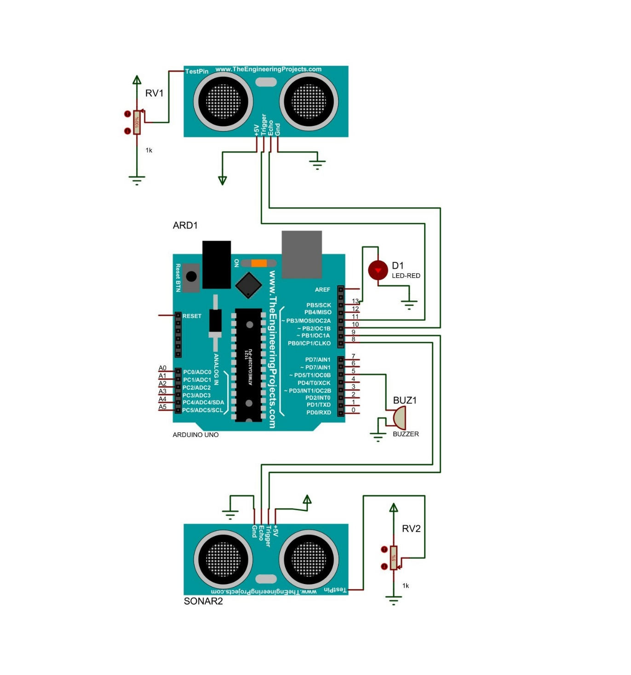

## 3.3 Block diagram

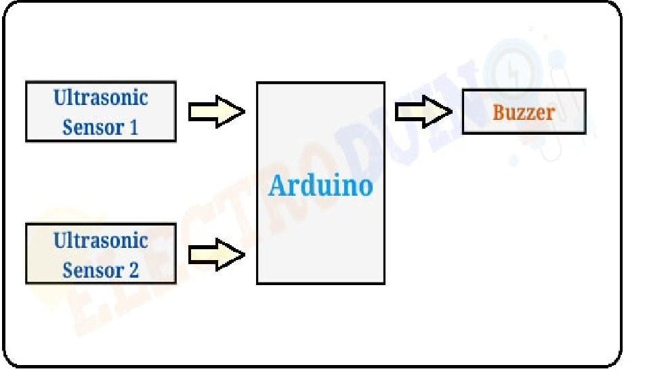

## 3.4 Connections

CONNECTIONS OF TWO ULTRA SONIC SENSOR CONNECTION WITH ARDUINO

FIRST ULTRASONIC SENSOSOR

1.Vcc----------------------------------5v pin

2.TrigPin1----------------------------------- 11th pin

3.EchoPin1----------------------------------10th pin

4.Gnd-----------------------------------------gnd pin

SECOND ULTRASONIC SENSOR

1.Vcc----------------------------------5v pin

2.TrigPin1----------------------------------- 9th pin

3.EchoPin1----------------------------------8th pin

4.Gnd-----------------------------------------gnd pin

BUZZER CONNECTION WITH AURDINO

1.+ve leg(big leg)---------------------------5th pin

2.-ve leg (small leg)-----------------------------gnd pin

LED CONNECTION WITH AURDINO

1.+ve leg(big leg)---------------------------13th pin

2.-ve leg (small leg)-----------------------------gnd pin

## 3.5 Arduino code

// Define the pins for the first ultrasonic sensor

const int trigPin1 = 11;

const int echoPin1 = 10;

// Define the pins for the second ultrasonic sensor

const int trigPin2 = 9;

const int echoPin2 = 8;

// Define the pins for the buzzer and LED

const int buzzerPin = 5;

const int ledPin = 13;

// Define variables

long duration1, duration2;

int distance1, distance2;

int threshold = 40; // The threshold distance in cm

void setup()

 {

  // Set the pins as inputs and outputs

  pinMode(trigPin1, OUTPUT);

  pinMode(echoPin1, INPUT);

  pinMode(trigPin2, OUTPUT);

  pinMode(echoPin2, INPUT);

  pinMode(buzzerPin, OUTPUT);

  pinMode(ledPin, OUTPUT);

  // Start the serial communication

  Serial.begin(9600);

}

void loop()

{

  // Clear the trigger pin for the first ultrasonic sensor

  digitalWrite(trigPin1, LOW);

  delayMicroseconds(2);

  // Send a 10 microsecond pulse to the trigger pin for the first ultrasonic sensor

  digitalWrite(trigPin1, HIGH);

  delayMicroseconds(10);

  digitalWrite(trigPin1, LOW);

  // Measure the duration of the pulse on the echo pin for the first ultrasonic sensor

  duration1 = pulseIn(echoPin1, HIGH);

  // Calculate the distance in cm for the first ultrasonic sensor

  distance1 = duration1 / 58.2;

  // Print the distance to the serial monitor for the first ultrasonic sensor

  Serial.print("Distance1: ");

  Serial.print(distance1);

  Serial.println(" cm");

  // Clear the trigger pin for the second ultrasonic sensor

  digitalWrite(trigPin2, LOW);

  delayMicroseconds(2);

  // Send a 10 microsecond pulse to the trigger pin for the second ultrasonic sensor

  digitalWrite(trigPin2, HIGH);

  delayMicroseconds(10);

  digitalWrite(trigPin2, LOW);

  // Measure the duration of the pulse on the echo pin for the second ultrasonic sensor

  duration2 = pulseIn(echoPin2, HIGH);

  // Calculate the distance in cm for the second ultrasonic sensor

  distance2 = duration2 / 58.2;

  // Print the distance to the serial monitor for the second ultrasonic sensor

  Serial.print("Distance2: ");

  Serial.print(distance2);

  Serial.println(" cm");

  // Check if the distance is less than the threshold

  if (distance1 <= threshold || distance2<= threshold)

  {

    // Turn on the buzzer and LED

    digitalWrite(buzzerPin, HIGH);

    digitalWrite(ledPin, HIGH);

  }

  else

  {

    // Turn off the buzzer and LED

    digitalWrite(buzzerPin, LOW);

    digitalWrite(ledPin, LOW);

  }

  // Wait for 100 milliseconds

  delay(100);

}

## 3.6 Gantt chart

|  |  |  |  |  |  |  |
| --- | --- | --- | --- | --- | --- | --- |
| S.N | Task | Week1 | Week2 | Week3 | Week4 | Week5 |
| 1 | Planning |  |  |  |  |  |
| 2 | Analysis |  |  |  |  |  |
| 3 | Designing |  |  |  |  |  |
| 4 | Coding |  |  |  |  |  |
| 5 | Testing |  |  |  |  |  |
| 6 | Documentation |  |  |  |  |  |

# Chapter 4

# System Development and Implementation

## 4.1 Software Specifications

Computer software specification we have used for development:

* Operating System: Windows 10 Operating System
* Keil uVision5
* Proteus 8 Professional

## 4.2 Hardware Specifications

Computer hardware specification we have used for development:

* Processor: Intel Core i5
* RAM: 8GB
* SSD: 512GB

# Chapter 5

# Conclusion

## 5.1 Conclusion

* Overall, the Smart Electronic Guiding Stick has the potential to greatly improve the quality of life for blind people, providing them with a safer and more independent means of navigation.
* The project demonstrates the power of technology in addressing real-world problems and creating positive social impact
* Technology can drive innovation for social impact.
* System can be customized to meet different user needs.
* Investment in assistive technologies is crucial for accessibility and inclusion.

## 5.2 Future scope

* Add GPS technology for better navigation and guidance
* Increasing the detection range of the ultrasonic sensor to identify obstacles from a greater distance
* Adding infrared or LIDAR sensors for greater accuracy in detecting obstacles
* Designing the smart blind stick to be more aesthetically appealing and customizable
* Integrating a rechargeable battery to increase convenience for the user

# References

https://projecthub.arduino.cc/hadi1234/b3157a03-4def-4366-942a-14b91202929d?fbclid=IwAR3cY9xXo1O5AtP2u3Qv9vkVXkzt06TngORnAJf3OW7C9wmQujDf0-t4VEQ

https://techatronic.com/smart-blind-stick-using-arduino-and-ultrasonic-sensor/?fbclid=IwAR2b9p3VmD7Wl6IpiGjVmrSNPOxSZXjW4Dv0HEwZUVNJX59acc4aacQnufM